
Assessment Cover Page
Student Full Name | Pedro Henrique Rodrigues de Andrade Netto
Student Number | 2026083
Module Title | Machine Learning for Business
Assessment Title | CA1
Lecturer/Supervisor | Dr. Muhammad Iqbal
Assessment Due Date | Friday 30th October 2026@23:59 (IST)
Date of Submission | Friday 30th October 2026

Video presentation
https://drive.google.com/file/d/1AiLhMGiCwi90xtsBbabAQXGX5rl4uzL6/view?usp=drive_link

Declaration of AI Use — AI Fluency Framework
This assessment applies to CCT College Dublin's AI Fluency Framework — four interconnected competencies that ensure your engagement with AI is effective, efficient, ethical and safe: Delegation, Description, Discernment and Diligence. Full detail on what AI use is permitted for this assessment, and the evidence you must provide, is set out in your Assessment Brief.
Delegation  Setting goals and deciding whether, when and how to engage with AI. | Description  Effectively describing goals to prompt useful AI behaviours and outputs.
Discernment  Accurately assessing the usefulness of AI outputs and behaviours. | Diligence  Taking responsibility for what we do with AI and how we do it.
Adapted from the AI Fluency Framework (Dakan, Feller, Anthropic, 2025).

Filling Out the Cover Sheet
- Fill out the top section of the cover page with all the required information.
- Complete the Student Response column of the AI Declaration table in the appendix of this cover, evidencing your Delegation, Description, Discernment and Diligence.

Appendix: AI Declaration using the AI Fluency Framework
AI competence | Reflective prompts (to students) | Lecturer expectations | Student response
Delegation  Deciding whether & when to use AI | Identify the specific tasks in this assessment where you chose to use AI, and explain your reasoning. Where did AI add value? Where did you decide not to use it, and why? | For this assessment, Generative AI may be used only as a supporting tool for brainstorming and refining ideas, fine-tuning research questions, finding relevant information, drafting an outline, checking grammar, clarity and writing style, and other uses explicitly approved by the lecturer.  These uses support planning, research and communication. GenAI must not replace the student's own technical implementation, analysis, modelling, evaluation or interpretation, as these directly assess the learning outcomes. You may not copy and paste GenAI output in your submission. All GenAI use must be declared in the GenAI Tools Declaration (Appendix A). | As a non-native English speaker, I frequently use AI to help me understand the context of a given task—whether it’s in English or Portuguese—which gives me more confidence when carrying out the work. Furthermore, once I’ve finished a task, I ask the AI ​​to check my grammar to ensure there are no mistakes with the language. I also turned to AI to investigate an anomaly in my dataset; the data showed a significant discrepancy, and I was curious to understand the reason behind this divergence.
Description  How you prompted the AI | Include the exact prompts you used in your appendix (recorded on the AI Tools declaration). Reflect on how you communicated your goals to the AI — did you need to iterate or refine your prompts to get useful output? | Students must provide evidence of prompting for all permitted GenAI use. The exact prompts used, together with relevant links, screenshots or evidence of prompt refinement where applicable, must be provided in Appendix B. Failure to do so is considered to be academic misconduct. | Here are the prompts I requested from Gemini. Attached in Appendix B are screenshots of the prompts and the results obtained:  - “Gemini, I am currently a data analytics student, and I need your help with the contextualization for a machine learning project. Could you help me with this? Please provide the explanation in both English and Portuguese.”  - “I’m working with a dataset on bicycle rentals in the U.S. during the years 2011 and 2012. I noticed a drastic drop in my data on October 29, 2012—could you help me figure out if there was any unusual event in the country on that date?”  - “Since I am not a native English speaker, could you check for any grammatical mistakes in what I’ve done before I send it? I am Brazilian, also my English is B2, and I would appreciate some feedback—without changing the proficiency level of the text.”
Discernment  Evaluating what the AI produced | In your reflection (~100 words), critically evaluate the AI output: what did you accept, modify, or reject — and why? Assess accuracy, relevance, and quality. You are responsible for verifying all AI-generated content before submitting. | A reflection is required for this assessment. In approximately 100 words, students must critically evaluate the accuracy, relevance and quality of any GenAI-assisted outputs, explaining what they accepted, modified or rejected and why. Failure to do so is considered to be academic misconduct. | Artificial intelligence is here to help us optimize our thinking capacity and achieve better results. I am careful not to let myself be influenced by it, nor do I use data that has been influenced by it. Using AI for contextualization and grammar checking is, in my view, a sound approach—a valuable asset that enhances my work without compromising my autonomy of thought. Regarding the curious anomaly: AI provided a shortcut to accessing information about the hurricane that struck the city being studied in the dataset. I therefore accepted this explanation, although I cannot prove with 100% certainty that this was the actual cause.
Diligence  Responsibility for your AI use | Declare all AI tools used and cite them here. Briefly outline (~100 words) how you considered data protection, copyright, and ethical responsibilities when choosing what to input into any AI system. Unauthorised use is subject to CCT disciplinary procedures. | Students must declare all GenAI tools used and cite them appropriately. In approximately 100 words, students must explain how they considered data protection, copyright and ethical responsibilities when using GenAI. Unauthorised GenAI use is subject to CCT disciplinary procedures. Failure to do so is considered to be academic misconduct. | Artificial intelligence is here among us; it is a reality. When used responsibly, it has the potential to maximize our ability to achieve results—but we must be the ones using it, rather than letting it use us. Since my dataset is public, I shared it—along with the work I developed—on the Gemini platform to request a grammatical review. Had I been working with a private dataset, I would have sought other ways to check my writing. Furthermore, without the research into the anomaly that occurred on the 28th, I would have found it difficult to account for climatic effects within my dataset.  Ultimately, my approach is to use it consciously and for the purpose of learning, ensuring that I remain in control rather than being dominated by it.

Appendix: Prompts Used on IA
- “Gemini, I am currently a data analytics student, and I need your help with the contextualization for a machine learning project. Could you help me with this? Please provide the explanation in both English and Portuguese.”

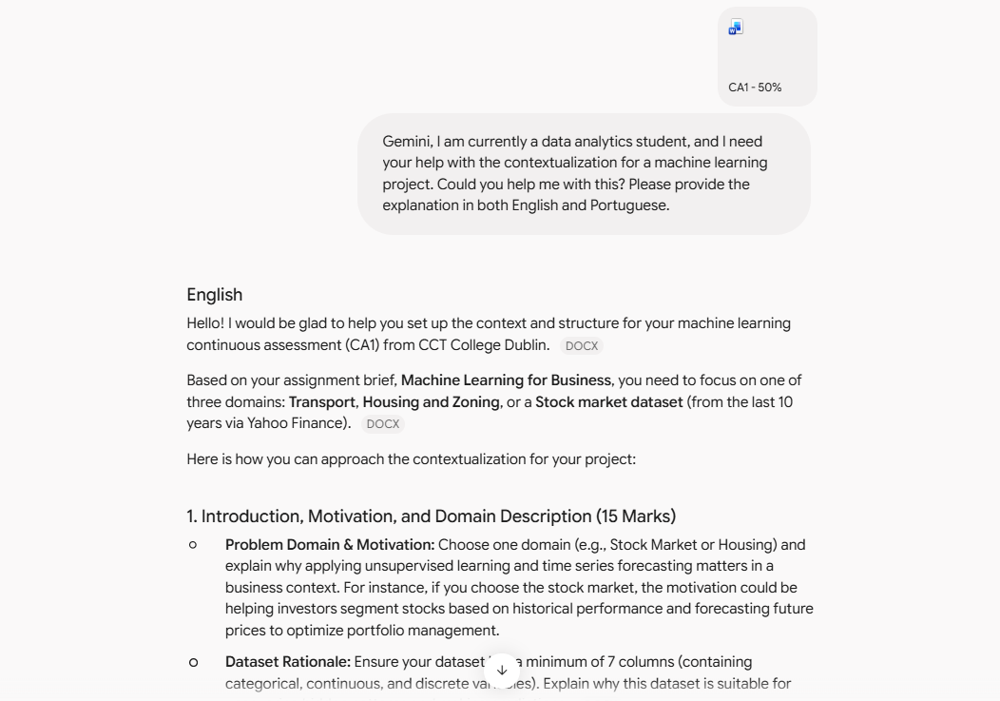

- “I’m working with a dataset on bicycle rentals in the U.S. during the years 2011 and 2012. I noticed a drastic drop in my data on October 29, 2012—could you help me figure out if there was any unusual event in the country on that date?”
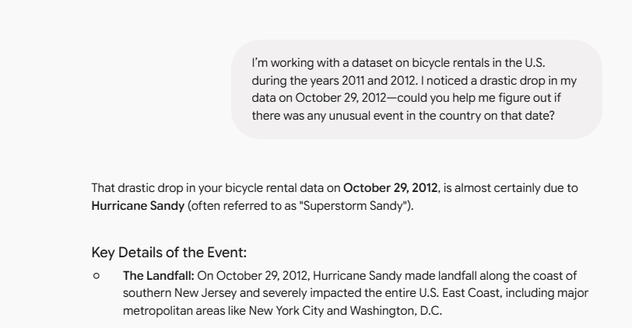

- “Since I am not a native English speaker, could you check for any grammatical mistakes in what I’ve done before I send it? I am Brazilian, also my English is B2, and I would appreciate some feedback—without changing the proficiency level of the text.”